**Logic Tutorial**

**ub2232e**

**000874782**

**USMAN BASHARAT**



**Logic Tutorial**

1. Use Boolean algebra and truth tables to solve the following.
   1. a + a =
   2. a . a =
   3. a + 1
   4. a . 1 =
   5. a . (b + b) =
   6. a . 0 =
   7. 1 =
   8. 0 =
   9. a + 0
   10. a + (b . b)
2. Use truth tables to prove the following equivalences.
   1. A . B . C  =  A + B + C
   2. A . B + A . C  =  ( B + C ) . A
   3. ( A + B ) . (  A + B )  =  B
3. Draw Venn diagrams for each of the following expressions.
   1. A + B
   2. A
   3. A + B
   4. A . B
   5. A
   6. A . B
4. Simplify the following expressions by Boolean algebra and verify by truth table.
   1. a . b + a . b
   2. a . ( a + b )
   3. a + ( a . b)
   4. a . ( b + c ) + a . c + a
   5. ( a + b ) . ( a + b )
   6. ( a . b ) + ( a . b )
   7. a . c + b . c + a . b . c
5. Write the Boolean expression in terms of AND, OR and NOT for each by the following truth tables.

|  |  |  |  |  |  |  |  |  |  |  |  |  |  |  |  |  |  |  |  |  |  |  |  |  |  |  |  |  |  |  |  |  |  |  |  |  |  |  |  |  |  |  |  |  |  |  |  |  |  |  |  |  |  |  |  |  |  |  |  |  |  |  |  |  |  |  |  |
| --- | --- | --- | --- | --- | --- | --- | --- | --- | --- | --- | --- | --- | --- | --- | --- | --- | --- | --- | --- | --- | --- | --- | --- | --- | --- | --- | --- | --- | --- | --- | --- | --- | --- | --- | --- | --- | --- | --- | --- | --- | --- | --- | --- | --- | --- | --- | --- | --- | --- | --- | --- | --- | --- | --- | --- | --- | --- | --- | --- | --- | --- | --- | --- | --- | --- | --- | --- |
| |  |  |  | | --- | --- | --- | | A | B | Z | | 0 | 0 | 0 | | 0 | 1 | 1 | | 1 | 0 | 1 | | 1 | 1 | 1 | |  | |  |  |  | | --- | --- | --- | | A | B | Z | | 0 | 0 | 0 | | 0 | 1 | 0 | | 1 | 0 | 0 | | 1 | 1 | 1 | |  | |  |  |  | | --- | --- | --- | | A | B | Z | | 0 | 0 | 1 | | 0 | 1 | 1 | | 1 | 0 | 0 | | 1 | 1 | 1 | |  | |  |  |  | | --- | --- | --- | | A | B | Z | | 0 | 0 | 1 | | 0 | 1 | 0 | | 1 | 0 | 1 | | 1 | 1 | 1 | |  |
| |  |  |  | | --- | --- | --- | | A | B | Z | | 0 | 0 | 1 | | 0 | 1 | 1 | | 1 | 0 | 1 | | 1 | 1 | 0 | |  | |  |  |  | | --- | --- | --- | | A | B | Z | | 0 | 0 | 1 | | 0 | 1 | 0 | | 1 | 0 | 0 | | 1 | 1 | 0 | |  | |  |  |  | | --- | --- | --- | | A | B | Z | | 0 | 0 | 1 | | 0 | 1 | 0 | | 1 | 0 | 0 | | 1 | 1 | 1 | |  | |  |  |  | | --- | --- | --- | | A | B | Z | | 0 | 0 | 0 | | 0 | 1 | 1 | | 1 | 0 | 1 | | 1 | 1 | 0 | |  |

1. Draw the logic circuit for the following Boolean expressions.
   1. z = a . ( b + c )
   2. z = a + ( b . c )
   3. z = a . b + b . c
   4. z = ( a + b ) . c
   5. z = a . b . c + b . c
   6. z = a . ( b + c ) + a . c + a
   7. Z = A . B + A . B + A . B
   8. z = (a + b + c) . ( a + b ) . c
   9. z = a . b . c + a + c + b . c
   10. z = a . b . c . ( a + b )
2. Write down the Boolean expressions for the following logic circuits.
   1. 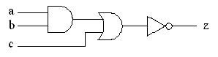
   2. 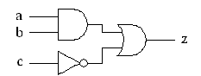
   3. 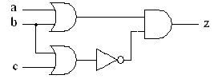
   4. 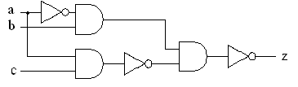
   5. 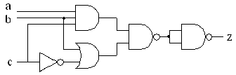
3. Write down the Boolean expressions for the following logic circuits, simplify the expressions and verify by truth table.
   1. 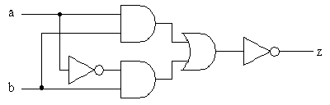
   2. 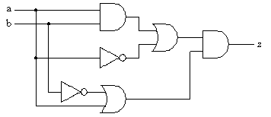
4. Write expressions for p, q and r. State z in terms of a and b, simplify the expression and verify by truth table.
   1. 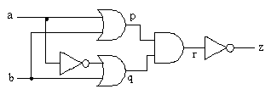
5. Write expressions for p, q , r and s State z in terms of a and b, simplify the expression and verify by truth table.
   1. 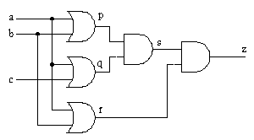
6. Simplify the following expressions and verify by truth table. Draw the circuits and then redraw each one using firstly only NAND gates and then using only NOR gates.
   1. z = ( a + b ) . c
   2. z = a . b + c
   3. z = ( a + b ) . (a + c ) . ( b + c )
   4. z = ( a . b ) + (b . c) + ( a . c )
7. Using a half-adder as the starting point, design a logic circuit to produce a full-adder.
8. A 3 bit binary number is represented by A2 A1 and A0, where A2 A1 and A0 represent the individual bits with A0 equal to the least significant bit. Design a logic circuit that will determine when the binary numbers are greater than 4.
9. Develop a logic circuit that can be used to compare two 3 bit binary numbers. If the numbers are called X and Y then your circuit should be able to detect if X = Y, X > Y or X < Y.
10. Simply the following expressions using Karnaugh maps
    1. z = a . b + a . b
    2. z = ( a . b . c . d ) + ( a . b . c . d ) + ( a . b . c . d ) + ( a . b . c . d ) + ( a . b . c . d ) + ( a . b . c . d )
    3. z = ( a . b . d ) + ( b . c . d ) + ( a . b . c . d )
11. What is meant by a flip flop? How can such a circuit be set up to act as a memory element within a computer system?
12. Illustrate how a shift register may be constructed from JK flip-flops. Where is a shift register used in a computer's architecture.
13. Illustrate how a binary counter may be constructed from JK flip flops. Adapt the circuit to make the counter count down instead of up. Where is a counter used  in computer's architecture.